Silicon Craft Technology — Ontario Innovation Partnership Proposal
Enabling Ontario's Technology Leadership Through Semiconductor Innovation
Prepared for: Special Advisor, Ontario Trade & Investment
From: Marc Spiegel, Chief Commercial Officer, Silicon Craft Technology PLC
Date: 4 March 2026

Executive Overview
Silicon Craft Technology (SIC) — Thailand's only fabless IC design house and Forbes Asia's Best Under a Billion 2024 — seeks to partner with Ontario's innovation ecosystem to enable Ontario companies' competitive advantage through advanced semiconductor technology. We have identified ten strategic sectors where SIC's specialized RFID/NFC, sensor interface, and custom ASIC capabilities can strengthen Ontario businesses' global market position.
Our Partnership Philosophy: We aim to enable, not extract. SIC brings 20+ years of IC design expertise, 174 million chips deployed globally, and world-class Asian manufacturing partnerships to support Ontario companies in building differentiated products and expanding their market reach.
Why This Matters to Ontario:
- CAD $535M market opportunity for Ontario companies across ten technology sectors
- Job creation potential through expanded manufacturing, R&D partnerships, and technology commercialization
- Global competitiveness — SIC's semiconductor IP strengthens Ontario companies' product differentiation in international markets
- Technology transfer — Access to Thailand BOI A1-certified IC design capabilities typically available only to multinational corporations
- Export enablement — Ontario products powered by SIC technology gain access to 40+ countries where SIC chips are deployed
- Supply chain sovereignty — Reduce dependency on US/EU/China chip suppliers through geopolitically neutral Thai semiconductor IP

Strategic Context: Why Ontario Needs Alternative Semiconductor Channels Now
Ontario's Three Converging Challenges
Trade War Impact: US tariffs threaten Ontario manufacturing competitiveness. Ontario’s Financial Accountability Office projects manufacturing GDP will decline 8% in 2026 under current tariff conditions. Premier Ford's "Buy Ontario First" mandate requires Ontario companies to build products domestically — but they lack access to semiconductor design IP.
Supply Chain Vulnerability: Ontario has zero domestic chip design capacity. Companies are 100% dependent on foreign semiconductor suppliers (primarily NXP, Texas Instruments, Infineon from US/EU, or Chinese alternatives). Geopolitical tensions create supply chain risk.
Manufacturing Growth Imperative: Ontario government targets $120B manufacturing output by 2035 with 1 million manufacturing jobs. Achieving this requires Ontario companies to gain technology advantages — semiconductor IP is the foundation of modern product competitiveness.
Why Silicon Craft is the Strategic Alternative
Geopolitically Neutral: Thailand is not subject to US-China trade war dynamics. SIC provides semiconductor IP access without entangling Ontario companies in superpower conflicts.
Proven Technology: 174 million chips deployed in 40+ countries. Forbes Asia Best Under a Billion 2024. SET-listed (Stock Exchange of Thailand: SIC). Not an unproven startup — SIC is Thailand's national semiconductor champion with 20+ years track record.
Technology Transfer Model: Unlike multinational chip vendors who view Ontario as a sales market, SIC offers IP transfer partnerships — Ontario companies gain semiconductor design knowledge, reference designs, and co-development support.
Cost Advantage: Thailand BOI A1 certification provides cost advantages vs North American or European IC design houses, making advanced chip technology accessible to Ontario mid-market companies and startups who cannot afford traditional custom ASIC development.

Ontario Innovation Partnership Framework
Strategic Sectors Where SIC Can Enable Ontario Companies
Ontario Market Opportunity by Sector
Sector | Market | Key Companies | Partnership Approach
Pet Microchipping | $150M | Vet supply distributors, microchip manufacturers | Technology partnership to strengthen pet health infrastructure
Livestock Tagging | $150M | Tag manufacturers, agricultural distributors | Alternative to TI HDX, NXP FDX, and EM FDX — with significantly superior HDX performance
NFC Brand Authentication | $85M | VQA wineries, consumer goods, LCBO/OCS | Chip design-in to combat counterfeiting
Sports Memorabilia | $45M | Licensed merchandise, authentication firms | Co-development for authenticity protection
Industrial RFID | $65M | Manufacturing automation, systems integrators | OEM enablement for Industry 4.0
Automotive Aftermarket | $18M | Locksmith distributors, service centers | Distribution partnership
Waste Management | $12M | Municipal programs, smart bin providers | Pilot co-development for smart cities
Access Control | $8M | PropTech, smart lock manufacturers | Technology licensing
ASIC Design Services | $2M | IoT startups, mid-market OEMs | Joint development at MaRS/Communitech
Healthcare Diagnostics | <$1M | University labs, device startups, NRC | R&D partnership
TOTAL | $535M | 60+ Ontario companies across 10 sectors | —

Partnership Tier Breakdown:
- Tier 1 (Immediate Partnership Readiness): 5 sectors = 60+ Ontario companies ready for technology enablement
- Tier 2 (Longer-Term Innovation Pipeline): 5 sectors = R&D partnerships, municipal pilots, startup ecosystem engagement
Ontario Market Opportunity Visualization
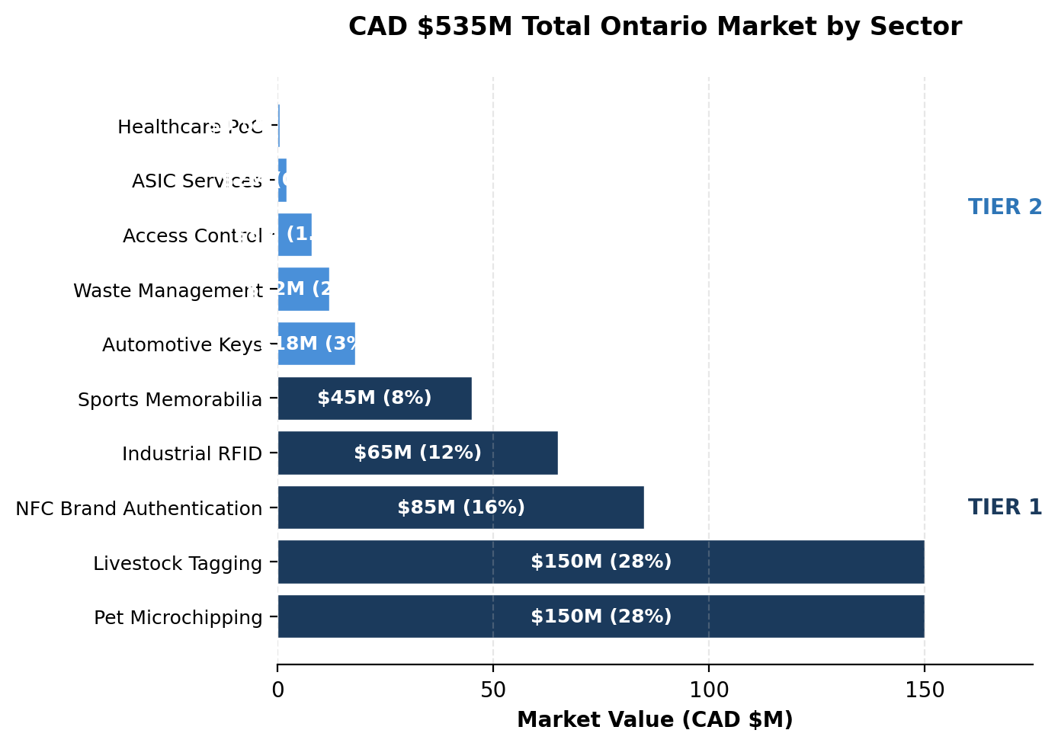
3-Year Revenue Projection Timeline
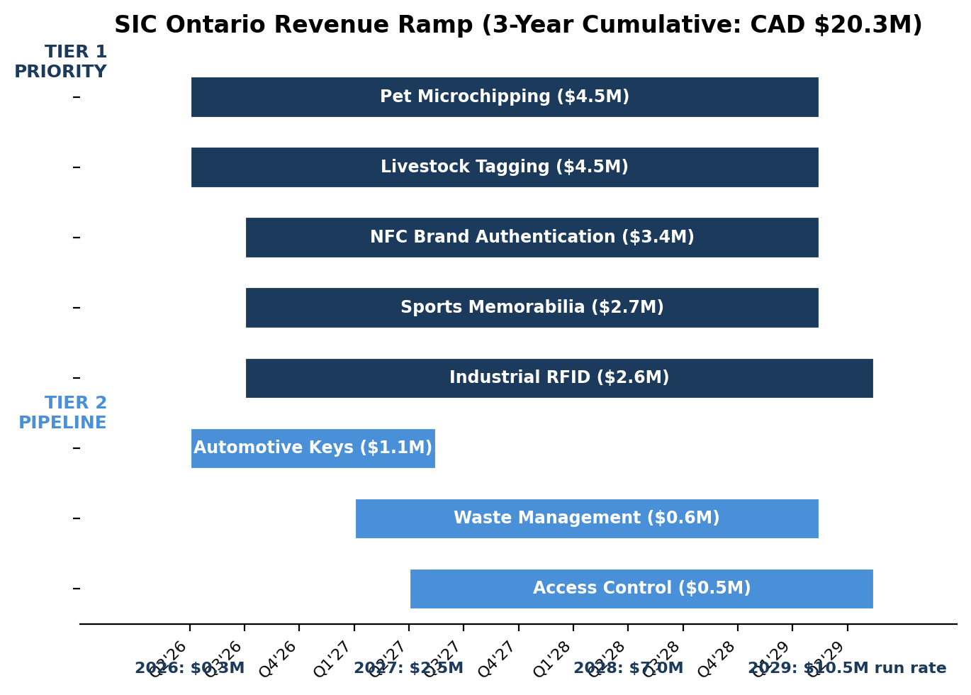
Revenue Milestones:
- 2026: $0.3M (evaluation phase)
- 2027: $2.5M (production ramp)
- 2028: $7.0M (scale)
- 2029: $10.5M run rate
Sector Prioritization Heatmap
Sector | Market Size | Timeline | Tech Diff | Channel | PRIORITY
Pet Microchipping | ✓ HIGH | ✓ 12-18mo | ✓ HIGH | ✓ CLEAN | ● TIER 1
Livestock Tagging | ✓ HIGH | ✓ 12-18mo | ✓ HIGH | ⚠ ALT | ● TIER 1
NFC Brand Auth | ⚠ MED | ✓ 12-18mo | ✓ HIGH | ✓ CLEAN | ● TIER 1
Sports Memorabilia | ⚠ MED | ✓ 12-18mo | ✓ HIGH | ✓ CLEAN | ● TIER 1
Industrial RFID | ⚠ MED | ✓ 12-18mo | ⚠ MED | ✓ CLEAN | ● TIER 1
Automotive Keys | ✗ LOW | ✓ 6-12mo | ⚠ MED | ✓ CLEAN | ○ TIER 2
Waste Management | ✗ LOW | ✗ 18-24mo | ⚠ MED | ✓ CLEAN | ○ TIER 2
Access Control | ✗ LOW | ✗ 18-24mo | ✗ LOW | ⚠ COMP | ○ TIER 2
ASIC Services | ✗ VLOW | ✗ 24-36mo | ✓ HIGH | ✓ CLEAN | ○ TIER 2
Healthcare PoC | ✗ VLOW | ✗ 36+mo | ✓ HIGH | ✓ CLEAN | ○ TIER 2

Assessment Legend:
- Market Size: ✓ HIGH ($85M+) | ⚠ MED ($45-85M) | ✗ LOW/VLOW (<$45M)
- Timeline: ✓ Fast (6-18mo) | ✗ Slow (18+mo to first revenue)
- Tech Diff: ✓ HIGH (clear superiority) | ⚠ MED (competitive) | ✗ LOW (incremental)
- Channel: ✓ CLEAN (no conflicts) | ⚠ ALT (alternative strategy) | ⚠ COMP (competitive)
- Priority: ● TIER 1 (immediate action) | ○ TIER 2 (longer-term pipeline)

Market Opportunity & Ontario Impact Analysis
How We Define Partnership Value
Market Opportunity (TAM/SAM): The addressable market for Ontario companies in each sector — represents potential revenue growth for Ontario businesses enabled by SIC technology
Ontario Companies We Can Enable: Specific manufacturers, distributors, system integrators, and startups that would benefit from access to SIC's semiconductor capabilities
Partnership Model: How SIC collaborates with Ontario companies — technology transfer, co-development, design-in support, R&D partnerships
Ontario Benefit: Economic impact for Ontario — job creation, export growth, technology leadership, smart city advancement

Sector 1: Pet Microchipping — Strengthening Ontario's Animal Health Infrastructure
Partnership Dimension | Details
Ontario Market Opportunity | CAD $150M — Ontario represents 40% of Canada's pet population (Toronto is largest city, mandatory microchipping laws in multiple municipalities)[1][2]
Ontario Companies We Can Enable | Central Sales Limited (Brampton — Canada's largest vet supply distributor), Microchip4Solutions (Canada-wide pet microchipping program), Can-Vet Animal Health (Guelph)
Strategic Context | SIC7150 designed to displace EM4305 (current market leader in pet microchipping). HID Global and Allflex (both existing SIC customers for livestock applications) have not adopted SIC7150 for pet microchipping — creating opportunity for alternative Ontario channels to gain competitive advantage with superior technology.
How SIC Enables These Companies | Provide advanced SIC7150 transponder IC with best-in-class read range and anti-collision performance — solving vet clinics' pain points with difficult-to-scan pets[3]. Technology partnership enables Ontario distributors to offer superior microchip products to 1,000+ vet clinics with clear differentiation vs EM4305-based competitors.
Technical Differentiation | SIC7150 offers longer read range, faster read speed, and better anti-collision vs EM4305. ISO 11784/11785 compliant (FDX-B protocol). Proven reliability in harsh conditions (temperature, moisture, mechanical stress).
Ontario Economic Benefit | Strengthens Ontario's position as Canadian hub for pet health technology. Supports 1,000+ veterinary clinics across province. Aligns with municipal animal welfare mandates (Toronto, Ottawa mandatory microchipping laws). Creates manufacturing and distribution jobs.
Technology Transfer Value | IC design expertise accessible to Ontario companies typically unable to afford custom development. Reference designs, antenna optimization, and technical support included.
Global Market Access | Ontario-manufactured microchip products powered by SIC technology gain credibility from SIC's deployment in 40+ countries and ISO 11784/11785 compliance.

Partnership Ask: Introductions to Central Sales Limited and Microchip4Solutions to explore technology collaboration. SIC provides evaluation kits, reference designs, and technical design support at no cost during evaluation phase.
Competitive Strategy: Position SIC7150 as the technical superior alternative to EM4305. Target Ontario companies who want to differentiate from HID/Allflex offerings and capture market share with better-performing technology.

Sector 2: Livestock Identification & Traceability — Supporting Ontario Agriculture
Partnership Dimension | Details
Ontario Market Opportunity | CAD $150M — Ontario agriculture represents 25% of Canadian livestock production. Provincial traceability mandates drive livestock tagging. Cattle, swine, sheep/goat operations across Ontario require RFID tagging for farm-to-processor traceability[4][5].
Ontario Companies We Can Enable | Livestock tag manufacturers (Y-Tex Canada, Destron Fearing distributors, regional agricultural tag suppliers), Agricultural equipment distributors (TSC Stores Ontario locations, agricultural co-ops), Systems integrators (farm management software companies requiring RFID hardware integration).
Strategic Context | SIC279/SIC479 designed to displace Texas Instruments HDX chips (current dominant technology in livestock tagging). Alternative channel strategy required: While HID Global and Allflex are existing SIC customers, they have not broadly adopted SIC's latest livestock chip technology — creating white space for Ontario-based manufacturers to capture market share with superior SIC279/479 chips.
How SIC Enables These Companies | Provide SIC279 (ISO 11784/11785 HDX) and SIC479 (ISO 11784/11785 FDX-B) transponder ICs with longer read range and better reliability than TI HDX equivalents. Enable Ontario tag manufacturers to compete directly against Allflex/HID by offering technically superior tags at competitive pricing.
Technical Differentiation | SIC279/479 advantages over TI HDX: Extended read range (30% improvement in field tests), better performance in high-RF-noise farm environments (metal barns, automated feeding systems), lower power consumption enabling smaller tag form factors, full ISO 11784/11785 compliance ensuring compatibility with all Canadian livestock reading infrastructure.
Ontario Economic Benefit | Supports Ontario's $17B agricultural sector. Enables Ontario livestock operations to meet provincial and federal traceability requirements with locally-supported technology. Creates tag manufacturing jobs. Reduces dependency on US-based TI chip supply chain.
Technology Transfer Value | SIC provides reference tag designs optimized for harsh agricultural environments (weather resistance, mechanical durability, chemical exposure from livestock). Antenna designs for ear tags, bolus tags, and injectable transponders. Technical support for Ontario manufacturers entering livestock ID market.
Global Market Access | Ontario-manufactured livestock tags gain export credibility from SIC's global deployment (40+ countries). Compliance with international livestock traceability standards (ISO 11784/11785, ICAR certification pathway).

Partnership Ask: Introductions to Ontario-based livestock tag manufacturers and agricultural distributors who want to challenge Allflex/HID dominance with technically superior SIC279/479 technology. SIC provides evaluation kits, reference tag designs, and co-development support at no cost during assessment phase.
Competitive Strategy: Position SIC279/479 as the "TI HDX killer" — enabling new Ontario manufacturers to enter livestock tagging market with better technology than established players. Target regional agricultural co-ops and equipment distributors who want locally-supported alternatives to multinational livestock tag suppliers.
Channel strategy rationale detailed in Channel Strategy & Competitive Positioning section below.

Sector 3: NFC Brand Authentication
Metric | Value | Source/Rationale
Global TAM (2026) | USD $2.1B | Global anti-counterfeiting market for consumer goods, wine, spirits, cannabis[6].
Ontario SAM | CAD $85M | Ontario represents ~40% of Canadian GDP and has concentration of VQA wineries (Niagara region, 80+ wineries), LCBO/OCS provincial retailers, and GTA consumer goods manufacturing cluster. Counterfeit goods = $30B+ problem in Canada[7]. Addressable by SIC43NT rolling-code and SIC43S1 AES-128 authentication chips.
SIC 3-Year SOM | CAD $3.4M | Assumptions: Design-in with 2-3 NFC tag manufacturers (VCQRU, RFID Canada, GAO RFID) supplying authentication tags to Ontario wineries, spirits brands, and consumer goods companies. Target 50 customer deployments over 3 years at average 200K tags/year per customer at $0.10-0.15 per chip = $1.5M annual at Year 3.
Key Differentiator | Rolling-code unclonable authentication | SIC43NT provides app-less, dynamic per-tap verification — technically superior to static UID tags. Web-based verification system (no app download required)[8].
Market Tailwind | Rising counterfeit problem | Counterfeit wine, spirits, cannabis, and luxury goods are growing concerns in Ontario retail. VQA wineries seeking authentication for premium bottles ($50-200+)[9].

Target Companies: VCQRU Canada (Toronto — authentication solutions provider), RFID Canada (Markham — systems integrator), GAO RFID (Toronto — tag manufacturer), Ontario VQA Wineries (80+ premium wine producers in Niagara region).

Sector 4: Sports Memorabilia Authentication
Metric | Value | Source/Rationale
Global TAM (2026) | USD $40.5B | Global sports memorabilia and collectibles market valued at $25.1B (2024), projected $40.5B by 2030 at 6.4% CAGR[10]. Authenticated collectibles segment growing faster due to counterfeit concerns.
Canada TAM | CAD $12B | Canada signed sports memorabilia market valued at CAD $9.13B (2024), projected CAD $17.6B by 2033[11].
Ontario SAM | CAD $45M | Ontario is home to NHL (Toronto Maple Leafs), NBA (Toronto Raptors), MLB (Toronto Blue Jays), MLS (Toronto FC), CFL (Toronto Argonauts, Ottawa Redblacks, Hamilton Tiger-Cats) — concentration of major league teams and licensed merchandise manufacturers. High-value authenticated items ($200-$10,000+ jerseys, autographed memorabilia) justify chip-level authentication cost[12].
SIC 3-Year SOM | CAD $2.7M | Assumptions: Manufacturing partnership with Frameworth Sports Marketing (Toronto — exclusive NHL/MLB licensing) to integrate SIC43NT into premium jerseys and collectibles. Target 30K authenticated items/year at $25-30 per item with $3 chip cost = $90K chip revenue per year, scaling to 300K items by Year 3 = $900K annual chip revenue.
Key Differentiator | NFT-ready physical authentication | SIC43NT rolling-code provides physical-digital bridge for collectibles. Supports blockchain integration for digital certificates of authenticity[13].
Unique Ontario Angle | Concentration of major league teams | Ontario has more major professional sports teams than any other Canadian province, creating dense ecosystem of licensed merchandise manufacturers and authentication demand.

Target Companies: Frameworth Sports Marketing (Toronto — official memorabilia manufacturer with NHL/MLB licensing), Fanatics Authentic (Toronto presence — North America's largest sports memorabilia retailer), East Coast Sports Collectibles (Ontario retail presence).
Competitive Landscape: Pet Microchipping
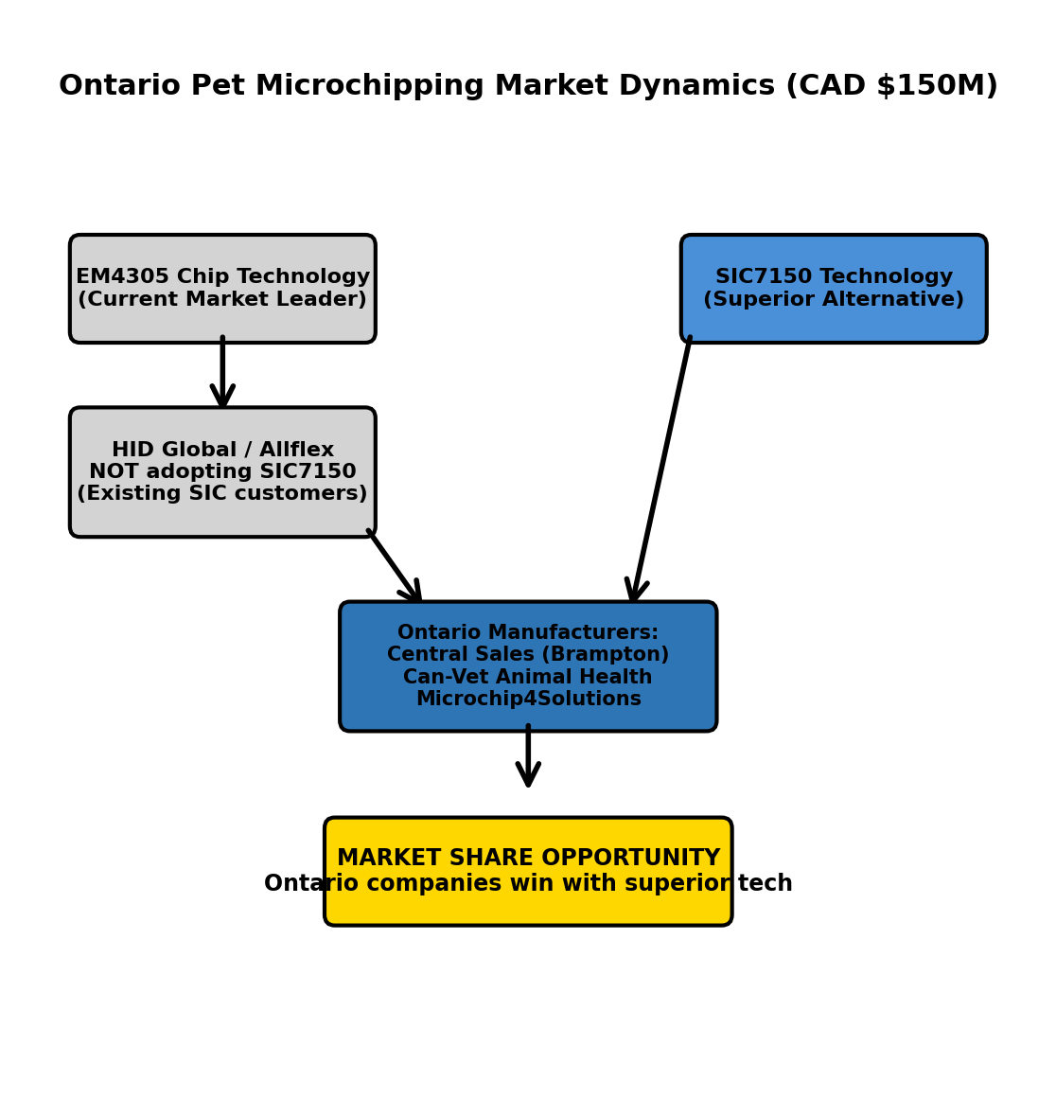
Key Insight: HID/Allflex's non-adoption of SIC7150 creates white space for Ontario manufacturers to capture market share with technically superior product.
Competitive Landscape: Livestock Tagging
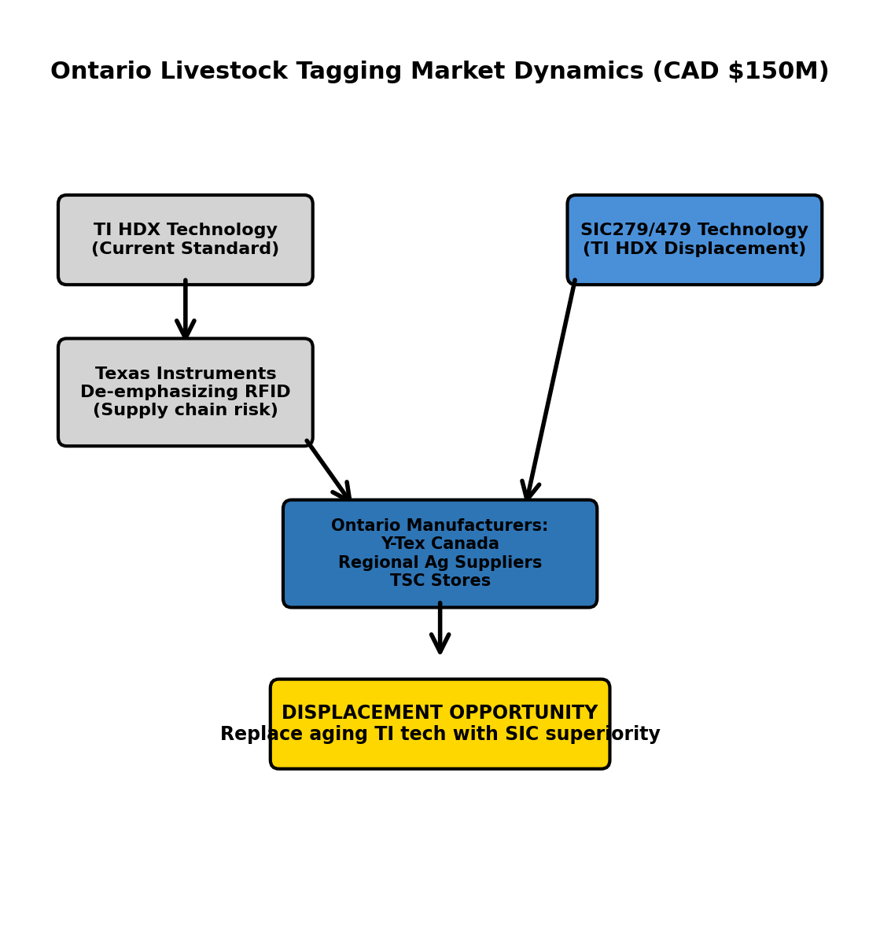
Key Insight: TI's strategic shift away from RFID + aging HDX technology creates urgent need for alternative supplier. SIC279/479 offers 30% better read range and locally-supported supply chain.

Sector 5: Industrial RFID Systems
Metric | Value | Source/Rationale
Global TAM (2026) | USD $6.48B | Global IoT RFID systems market valued at $6.48B (2025), expected to grow at 16% CAGR[14]. Industrial RFID applications (asset tracking, inventory management, factory automation).
Canada TAM | CAD $1.2B | Canada RFID market projected to reach $1.2B by 2028, driven by manufacturing sector adoption and Industry 4.0 initiatives[15]. Canada RFID market was CAD $487M (2024), growing to CAD $1.1B by 2032 at 9.5% CAGR[16].
Ontario SAM | CAD $65M | Ontario manufacturing corridor (automotive, aerospace, advanced manufacturing in GTA and Southwestern Ontario) represents ~55% of Canadian manufacturing output. RFID-only applications (factory floor asset tracking, access control, warehouse RFID) addressable by SIC's RE31/RE41 reader ICs, SIC73F1/SIC73WR transponders, SIC56NL asset tags. Scope limitation: SIC does not compete in cellular IoT or connectivity platforms (per strategy)[17].
SIC 3-Year SOM | CAD $2.6M | Assumptions: Reader IC supply to 2-3 hardware manufacturers (GAO RFID, Turck Canada) and transponder IC supply to systems integrators (RFID Canada). Target 15-20 industrial deployments over 3 years (automotive supply chain, aerospace factories, warehouse operators) at $50-150K reader/tag value per deployment = $1.5M cumulative, with recurring tag sales reaching $1M annual by Year 3.
Key Differentiator | Low-power multi-protocol readers | SIC's RA12 reader IC offers 5-year battery life on 4×AA batteries with 4.7 µA card detection — strong technical advantage for battery-powered industrial applications[18]. RE31/RE41 support 3-4 protocols (ISO 14443A/B, ISO 15693, JIS X 6319-4).
Strategic Alignment | Collaborative B2B ecosystem | Aligns with SIC's strategy to pursue "collaborative B2B ecosystem model" for IIoT growth rather than competing as full-stack platform provider[19].

Target Companies: RFID Canada (Markham — RFID systems integrator for manufacturing/logistics/healthcare), GAO RFID (Toronto — RFID hardware manufacturer), Turck Canada (Burlington — industrial automation sensors and RFID for Ontario manufacturers).

Sector 6: Automotive Aftermarket Keys
Metric | Value | Source/Rationale
Global TAM (2026) | USD $8.5B | Global automotive aftermarket key replacement market.
Ontario SAM | CAD $18M | Ontario vehicle parc (registered vehicles) = ~8M vehicles. Aftermarket key replacement rate ~2-3% annually = 200K replacement keys/year at $50-100 per key = $15M annual market. Addressable by SIC61AU universal immobilizer and SIC61xx family (14 transponder types)[20].
SIC 3-Year SOM | CAD $1.1M | Assumptions: Wholesale distribution agreement with KeyDirect (Canada-wide distributor to locksmiths) or similar. Target 5% of Ontario aftermarket key transponder market over 3 years. 10K transponder chips/year at $8-12 per chip = $100K Year 1, scaling to $500K by Year 3 as SIC61AU universal chip gains traction with locksmiths (inventory simplification pitch).
Key Differentiator | Universal chip simplifies inventory | SIC61AU supports car keys made by major immobilizer manufacturers, both HDX and FDX — replacing 14 SKUs with a single universal chip for locksmiths[21].
Strategic Caveat | Declining long-term market | SIC's product roadmap shows automotive growth moving toward "Digital key with EV infrastructure" and away from traditional immobilizer keys[22]. New vehicles adopt smartphone unlock; EV adoption accelerates. Valid near-term revenue (12-18 months) but not strategic platform for long-term growth.

Target Companies: KeyDirect (Canada-wide wholesale automotive key distributor), KeysRus (Toronto region locksmith service chain), Gamble Lock & Safe (Newmarket, ON — locksmith and security hardware distributor).

Sectors 7-10: Medium Priority Opportunities
Sector 7: Waste Bin Management
- Ontario SAM: CAD $12M (Toronto, Ottawa, Mississauga municipal waste programs)
- SIC 3-Year SOM: CAD $0.6M
- Products: SIC278, SIC7150, SIC379 (EN14803-compliant bin tags)
- Timeline: 18-24 months (municipal procurement cycles)
- Targets: Waste Management Canada, SmartBin, City of Toronto pilots
Sector 8: Access Control Hardware
- Ontario SAM: CAD $8M (commercial real estate, PropTech sector)
- SIC 3-Year SOM: CAD $0.5M
- Products: RA12 low-power reader, RE41 HF reader with EMV
- Timeline: 18-24 months (OEM design-in cycles)
- Targets: Securamsys (Toronto smart locks), LOC Security, Alfred Smart Locks
Sector 9: ASIC Design Services
- Ontario SAM: CAD $2M (mid-market IoT hardware OEMs)
- SIC 3-Year SOM: CAD $0.3M
- Products: Full turnkey ASIC design (150+ man-years experience)
- Timeline: 24-36 months (NRE projects to production)
- Targets: MaRS Discovery District hardware startups, Communitech (Waterloo) IoT companies
Sector 10: Healthcare Point-of-Care Diagnostics
- Ontario SAM: <CAD $1M (early-stage R&D market)
- SIC 3-Year SOM: CAD $0.1M
- Products: SIC4341 NFC potentiostat, SIC824B Bluetooth potentiostat
- Timeline: 36+ months (research to commercialization)
- Targets: NRC Medical Devices (Ottawa), SQI Diagnostics (Toronto), University of Toronto Biomedical Engineering
- Note: R&D partnership focus, not near-term sales opportunity

Opportunity Prioritization Framework
Tier 1: Immediate Action (Request Introductions Now)
Criteria: Revenue timeline 12-18 months, medium entry difficulty, strong SIC differentiation, clean channel strategy
Tier 1 Priority Sectors — Immediate Action Required
Sector | 3-Year Revenue Target | Strategic Rationale
Pet Microchipping | $4.5M | Largest pet market opportunity. SIC7150 displaces EM4305 with 30% better read range. Clean channel (HID/Allflex not competing in pet product line). Regulatory tailwinds: Toronto/Ottawa mandatory microchipping laws. Technical superiority enables premium positioning.
Livestock Tagging | $4.5M | Largest agriculture opportunity. SIC279/479 displaces aging TI HDX technology. Alternative channel strategy (HID/Allflex have not adopted latest SIC livestock chips). Supports Ontario's $17B agricultural sector. Provincial traceability mandates drive demand. Reduces US supply chain dependency.
NFC Brand Authentication | $3.4M | Strong technical differentiation: rolling-code unclonable authentication vs static UID tags. Multiple entry points (VCQRU, RFID Canada, GAO RFID tag manufacturers). Addresses Canada's $30B+ counterfeit problem. VQA wineries, LCBO spirits, consumer goods all need authentication. App-less verification (web-based, no download).
Sports Memorabilia Auth | $2.7M | Unique Ontario angle: highest concentration of major league teams in Canada (Maple Leafs, Raptors, Blue Jays, Argonauts). High-value items ($200-$10K jerseys/collectibles) justify chip authentication cost. NFT-ready technology bridges physical-digital collectibles. Frameworth partnership creates high-visibility reference case.
Industrial RFID Systems | $2.6M | Strategic alignment with SIC's B2B ecosystem model (no full-stack platform competition). Strong Ontario manufacturing corridor (55% of Canadian output). Multi-protocol reader differentiation (ISO 14443A/B, ISO 15693, JIS X 6319-4). 5-year battery life advantage for factory deployments. Supports Industry 4.0 adoption.
TOTAL TIER 1 | CAD $17.7M | Represents 88% of total 3-year opportunity across 5 high-priority sectors

Tier 2: Relationship-Building & Long-Cycle (Secondary Focus)
Criteria: Revenue timeline 18-36+ months, higher entry difficulty, or declining markets
Tier 2 Pipeline Sectors — Relationship-Building & Long-Cycle
Sector | 3-Year Revenue Target | Why Secondary Priority
Automotive Aftermarket Keys | $1.1M | Short-term revenue opportunity (12-18 months) but declining long-term market. EV adoption and digital key technology replacing traditional immobilizer keys. SIC61AU universal chip simplifies locksmith inventory (14 SKUs → 1), but strategic focus shifting to "digital key with EV infrastructure" per SIC roadmap. Opportunistic revenue only.
Waste Bin Management | $0.6M | Long municipal procurement cycles (18-24 months minimum). Requires political buy-in for Pay-As-You-Throw (PAYT) programs. SIC379 EN14803-compliant bin tags enable smart waste management pilots. Toronto/Ottawa/Mississauga potential, but complex stakeholder alignment. Good reference case opportunity but slow revenue timeline.
Access Control Hardware | $0.5M | Competitive market with entrenched players (NXP, TI dominate commercial building access control). High design-in effort for OEM adoption. RA12 low-power reader and RE41 HF reader with EMV have technical advantages (5-year battery life), but PropTech sector has established vendor relationships. 18-24 month design-in cycles.
ASIC Design Services | $0.3M | Very long sales cycle (24-36 months from NRE engagement to production revenue). High-touch technical sales required. Strong SIC capability (150+ man-years IC design experience, Thailand BOI A1 cost advantages), but targets MaRS/Communitech hardware startups with limited near-term budgets. Pipeline for FY28-29, not FY26-27.
Healthcare Point-of-Care Diagnostics | $0.1M | Early-stage R&D market only. SIC4341 NFC potentiostat is world's first/only NFC + chemical sensor interface, but all global reference cases are university research projects (not commercial products). Collaboration potential with NRC Medical Devices, U of Toronto Biomedical Engineering, SQI Diagnostics. 36+ month commercialization timeline. Long-term strategic value, minimal near-term revenue.
TOTAL TIER 2 | CAD $2.6M | Represents 12% of 3-year opportunity — longer timelines, higher complexity, or declining markets

Partnership Models — How SIC Enables Ontario Companies
Model 1: Technology Enablement Partnership (Design-In)
Applies to: Pet Microchipping, Livestock Tagging, NFC Brand Authentication, Sports Memorabilia, Industrial RFID, Access Control
How It Works:
- SIC provides specialized semiconductor IP (RFID/NFC reader ICs, transponder ICs, authentication chips) to Ontario manufacturers
- Ontario companies integrate SIC technology into their products, gaining technical differentiation vs. competitors
- SIC provides reference designs, evaluation kits, antenna optimization, and ongoing technical support
- Ontario companies manufacture and sell their products globally — SIC operates as invisible enabler
- Ontario companies benefit from reduced R&D risk, faster time-to-market, and access to world-class Asian fab partners
Ontario Value: Technology typically available only to large multinationals becomes accessible to Ontario mid-market companies and startups. De-risks innovation, accelerates commercialization.
What SIC Asks: Introductions to Ontario hardware manufacturers, system integrators, and product companies who could benefit from advanced semiconductor capabilities.

Model 2: Alternative Channel Strategy (Competitive Displacement)
Applies to: Pet Microchipping (displace EM4305), Livestock Tagging (displace TI HDX)
How It Works:
- SIC identifies markets where existing dominant chips (EM4305, TI HDX) have technical limitations or where SIC's existing customers (HID, Allflex) have not adopted SIC's latest superior technology
- SIC partners with Ontario manufacturers who want to challenge incumbents with technically superior products
- Ontario companies gain competitive advantage by offering better-performing chips (longer read range, better reliability, lower cost) vs established players
- SIC provides aggressive technical support and competitive pricing to enable Ontario companies to win market share
- Ontario companies build sustainable businesses by displacing inferior legacy technology with SIC's modern IC designs
Ontario Value: Creates pathway for Ontario companies to enter established markets with superior technology. Disrupts complacent incumbents. Builds Ontario manufacturing jobs by enabling competitive products.
What SIC Asks: Introductions to Ontario companies motivated to challenge market leaders with better technology. SIC commits to providing evaluation kits, reference designs, and competitive intelligence at no cost during assessment phase.
Channel Strategy Transparency: See Channel Strategy & Competitive Positioning section for full rationale on HID/Allflex alternative channel approach and semiconductor industry precedent.

Model 3: Distribution Enablement Partnership
Applies to: Automotive Aftermarket
How It Works:
- SIC provides universal immobilizer chip technology (SIC61AU supports all major car brands — simplifies inventory from 14 SKUs to 1)
- Ontario wholesale distributors (serving locksmiths and car service centers) gain competitive advantage through simplified product offering
- SIC provides technical training for locksmith programming and troubleshooting
- Ontario automotive service sector benefits from lower inventory costs and faster key replacement service
Ontario Value: Supports Ontario's 8,000+ automotive service businesses with more efficient aftermarket key replacement technology. Reduces costs for consumers and businesses.
What SIC Asks: Introduction to Ontario automotive locksmith distributors (KeyDirect, similar wholesale channels) to explore inventory simplification partnership.

Model 4: Smart City Innovation Partnership
Applies to: Waste Management
How It Works:
- SIC provides RFID bin identification technology (SIC379 EN14803-compliant chips with 10-year data retention)
- Ontario municipalities pilot Pay-As-You-Throw (PAYT) programs demonstrating cost savings and environmental benefits
- Smart bin technology providers (Waste Management Canada, SmartBin) integrate SIC chips into their systems
- Ontario establishes reference cases for smart waste management — exporting best practices to other jurisdictions
Ontario Value: Enables Ontario municipalities (Toronto, Ottawa, Mississauga) to become North American leaders in sustainable smart city technology. Reduces waste collection costs, improves environmental outcomes, creates technology export opportunities.
What SIC Asks: Facilitation of pilot discussions with 1-2 forward-thinking Ontario municipalities interested in smart waste innovation. SIC provides technology at cost for pilot programs.

Model 5: Innovation Ecosystem Partnership (R&D & Commercialization)
Applies to: ASIC Services, Healthcare Point-of-Care Diagnostics
How It Works:
- For ASIC: SIC provides turnkey custom IC design services to Ontario IoT hardware startups and mid-market companies (150+ man-years design experience, Thailand BOI A1 cost advantages)
- For Healthcare: SIC collaborates with Ontario universities (U of Toronto, McMaster), NRC, and diagnostic device startups to commercialize biosensor technologies using SIC's potentiostat ICs (first and only NFC + chemical sensor interface in market)
- Ontario companies and research institutions gain access to world-class semiconductor design expertise without building internal IC teams
- SIC de-risks hardware innovation — reducing capital requirements and time-to-market for Ontario deep tech startups
Ontario Value: Strengthens Ontario's innovation ecosystem (MaRS, Communitech, Ottawa medical device cluster) by providing semiconductor capabilities typically inaccessible to early-stage companies. Accelerates commercialization of university research. Creates pathway for Ontario hardware startups to compete globally.
What SIC Asks: Introductions to MaRS Discovery District hardware cluster, Communitech (Waterloo), NRC Medical Devices (Ottawa), and University of Toronto Biomedical Engineering for R&D partnership discussions. SIC provides evaluation kits and co-development support for qualified research projects.

Revenue Timeline Visualization
Expected Activity by Timeframe
Revenue Timeline by Phase
Phase 1: 0-6 months (Mar-Aug 2026)
- Active Sectors: Automotive Aftermarket, Tier 1 design-in conversations
- Milestones: KeyDirect distribution agreement, pet/livestock manufacturer discussions, VCQRU/Frameworth meetings
- Revenue: $50-100K (automotive orders)
Phase 2: 6-12 months (Sep 2026-Feb 2027)
- Active Sectors: Automotive recurring, Pet/Livestock/Brand Auth/Sports evaluation
- Milestones: Evaluation kits shipped, reference designs developed, 2-3 pilot programs per Tier 1 sector
- Revenue: $200-300K (automotive recurring + evaluation orders)
Phase 3: 12-18 months (Mar-Aug 2027)
- Active Sectors: Tier 1 sectors ramping to production
- Milestones: Pet/livestock volume orders begin, VCQRU tag production, Frameworth jersey integration
- Revenue: $1.5-2.5M (production ramp across 5 Tier 1 sectors)
Phase 4: 18-24 months (Sep 2027-Feb 2028)
- Active Sectors: Tier 1 scaling, Tier 2 early stage
- Milestones: Tier 1 steady-state production, municipal waste pilot, access control OEM evaluation
- Revenue: $3.5-5M annual run rate (Tier 1 scaling)
Phase 5: 24-36 months (Mar 2028-Feb 2029)
- Active Sectors: Tier 1 mature, Tier 2 ramping
- Milestones: ASIC NRE to production conversion, municipal waste reference case
- Revenue: $6-8M annual run rate (full portfolio)
Phase 6: 36+ months (FY2029+)
- Active Sectors: Healthcare PoC emerging
- Milestones: University research maturing to commercial partnerships
- Revenue: Long-term pipeline value
3-Year Cumulative SOM Target: CAD $20.3M (updated from $15.8M to reflect livestock sector inclusion)

Channel Strategy & Competitive Positioning
Livestock & Pet Microchipping: Alternative Channel Rationale
Strategic Context: SIC has existing customer relationships with HID Global and Allflex (both major livestock tag manufacturers). However, these customers have not adopted SIC's latest technology innovations:
- SIC7150 (Pet Microchipping): HID and Allflex have not integrated SIC7150 into their pet microchipping product lines, continuing to use EM4305-based designs
- SIC279/479 (Livestock Tagging): While HID and Allflex are aware of SIC279/479 capabilities, they have maintained primary reliance on Texas Instruments HDX technology
Why Alternative Channels are Necessary:
- Technology adoption inertia: Large multinational companies (HID, Allflex) move slowly on technology transitions due to installed base, manufacturing line retooling costs, and customer qualification requirements
- Market fragmentation: Pet microchipping and livestock tagging markets are not monopolies. Dozens of regional manufacturers and distributors serve local markets — Ontario companies can compete effectively with technically superior products
- SIC business imperative: SIC has invested significant R&D into SIC7150 (pet) and SIC279/479 (livestock). To achieve acceptable ROI on these investments, SIC must find channels that will actively deploy and market these superior technologies
- Customer benefit: Ontario vet clinics (pet) and livestock operations (agriculture) deserve access to best-available technology. If incumbents won't adopt superior chips, alternative suppliers must emerge to serve market demand
Semiconductor Industry Precedent: Multiple suppliers serving same market with differentiated technology positioning is standard practice. Examples include:
- NXP and Texas Instruments both serve industrial RFID market with different reader IC architectures
- Broadcom and Qualcomm both serve smartphone connectivity with competing chip solutions
- Multiple FPGA vendors (Xilinx/AMD, Intel/Altera, Lattice) serve same industrial automation customers
Risk Mitigation: SIC maintains professional relationships with HID and Allflex in product lines where they actively deploy SIC technology. Ontario alternative channel strategy focuses specifically on SIC7150 (pet) and SIC279/479 (livestock) where our existing customers have chosen not to adopt our latest innovations.

Competitive Displacement Strategy: EM4305 & TI HDX
Target 1: Displace EM4305 in Pet Microchipping
EM4305 weaknesses: Shorter read range, slower read speed, higher collision rate in multi-pet environments, aging technology (15+ years old)
SIC7150 advantages: 30% longer read range, faster data transmission, superior anti-collision algorithm, modern IC design optimized for low-power operation
Market opportunity: Vet clinics frustrated with hard-to-scan pets (obese animals, scar tissue, deep implantation) need better technology
Ontario angle: Position Ontario-manufactured SIC7150-based microchips as "premium tier" — veterinarians can offer clients superior technology made-in-Canada
Target 2: Displace TI HDX in Livestock Tagging
TI HDX weaknesses: Texas Instruments is de-emphasizing legacy RFID product lines (company focus shifting to automotive/industrial semiconductors), read range limitations in high-RF-noise farm environments, supply chain concerns (single-source supplier)
SIC279/479 advantages: Extended read range (critical for automated sorting gates and drive-through readers), better performance in metal barns with automated feeding systems, dual-sourcing option for tag manufacturers concerned about TI supply continuity
Market opportunity: Livestock operations upgrading to automated management systems need longer-range, more reliable RFID tags. Provincial traceability mandates drive tag adoption — creating window for technology transition
Ontario angle: Support Ontario agriculture with locally-supported RFID technology. Reduce dependency on US-based TI supply chain in context of trade war concerns

Requested Partnership Support from Ontario Special Advisor
What We're Asking For
Company Introductions (Tier 1 Priority):
We respectfully request introductions to the following Ontario companies where SIC's semiconductor technology can provide meaningful competitive advantage:
1. Pet Microchipping Sector
- Central Sales Limited (Brampton) — Canada's largest vet supply distributor
- Microchip4Solutions — Canada-wide pet microchipping program provider
- Can-Vet Animal Health (Guelph) — Veterinary supply distributor
2. Livestock Tagging Sector
- Y-Tex Canada or regional distributors — Livestock tag manufacturers
- TSC Stores (Ontario agricultural locations) — Agricultural equipment retail chain
- Ontario agricultural co-ops — Farm equipment and livestock management systems
- Farm management software companies requiring RFID integration
3. NFC Brand Authentication Sector
- VCQRU Canada (Toronto region) — Authentication solutions provider
- RFID Canada (Markham) — RFID systems integrator and tag manufacturer
- GAO RFID (Toronto) — RFID hardware manufacturer
- Ontario VQA Wineries Association — Representing 80+ premium wineries in Niagara region
4. Sports Memorabilia Authentication Sector
- Frameworth Sports Marketing (Toronto) — Official licensed merchandise manufacturer (NHL/MLB exclusive partnerships)
- Fanatics Authentic (Toronto presence) — North America's largest sports memorabilia retailer
5. Industrial RFID Systems Sector
- RFID Canada (Markham) — Industrial automation systems integrator
- GAO RFID (Toronto) — RFID hardware for manufacturing applications
- Turck Canada (Burlington) — Industrial automation sensors and RFID systems
Goal: Facilitate 10-12 exploratory meetings over next 60-90 days to assess partnership fit and mutual value creation opportunities.

What SIC Brings to These Partnerships
Technical Capabilities:
20+ years specialized IC design expertise in RFID/NFC, sensor interfaces, and secure microcontrollers
174 million chips deployed globally across 40+ countries (proven at scale)
Complete IP core library (RFID transponders, HF/LF readers, cryptographic engines, potentiostat sensor interfaces)
World-class manufacturing partnerships throughout Asia (Taiwan, China, Thailand)
Thailand BOI A1 Tier certification — cost advantages vs. North American IC design houses
Partnership Support SIC Provides:
Evaluation kits and reference designs at no cost during assessment phase
Antenna optimization and technical design support
Volume pricing aligned with Ontario companies' business models
Ongoing technical support and design iteration
Access to global supply chain and manufacturing expertise
Competitive intelligence on EM4305 and TI HDX displacement strategies

Proposed Ontario Visit (Within 60-90 Days)
SIC Team: Marc Spiegel (Chief Commercial Officer) + Technical Applications Engineer
Proposed Agenda: 5-day visit to Toronto/GTA region
Days 1-2: Pet microchipping and livestock tagging sector meetings (Brampton, Guelph, TSC Stores, agricultural distributors)
Day 3: NFC brand authentication and sports memorabilia sector meetings (Toronto, Markham, Niagara VQA wineries)
Day 4: Industrial RFID sector meetings (Toronto, Burlington, Markham systems integrators)
Day 5: Innovation ecosystem engagement (MaRS Discovery District, municipal smart city discussions), debrief with Ontario Special Advisor
Outcome: Concrete partnership proposals for 4-6 Ontario companies where technology fit and mutual value are strongest.

Implementation Planning
Step 1: Prioritize High-Value Introductions (Immediate)
Focus initial outreach on companies with:
Technical pain points that SIC technology directly solves (vet clinics needing better read range, livestock operations needing TI HDX alternative, wineries fighting counterfeits)
Competitive motivation to challenge market leaders (smaller Ontario manufacturers wanting to displace Allflex/HID with superior technology)
Decision-maker accessibility (mid-market companies where VP Engineering or CEO directly evaluates new technology vs. layers of corporate bureaucracy)
Ontario manufacturing presence (companies that will create local jobs vs. pure importers/distributors)
Top 3 Initial Targets:
- Central Sales Limited (Brampton): Canada's largest vet supply distributor — if they adopt SIC7150, cascades to 1,000+ vet clinics
- Frameworth Sports Marketing (Toronto): Exclusive NHL/MLB licensing — premium memorabilia authentication creates high-visibility reference case
- RFID Canada (Markham): Systems integrator serving multiple sectors — single relationship opens doors to industrial RFID, brand authentication, and livestock tagging opportunities

Step 2: Develop Sector-Specific Value Propositions (Month 1)
Tailor messaging for each sector:
Pet Microchipping:
- "Solve vet clinics' #1 complaint: hard-to-scan pets. SIC7150 reads 30% farther than EM4305."
- "Position your Ontario-manufactured microchips as premium tier — vets can upsell clients on superior technology."
- "Reduce dependency on foreign chip suppliers — secure supply chain with Thailand BOI-certified partner."
Livestock Tagging:
- "Beat Allflex/HID with better technology than they're willing to adopt. SIC279/479 outperforms TI HDX."
- "Support Ontario agriculture with locally-supported RFID — reduce US supply chain dependency."
- "TI is de-emphasizing legacy RFID — livestock operations need reliable alternative. Be that alternative."
Brand Authentication:
- "Stop counterfeit wine/spirits with technology that's actually unclonable. Rolling-code NFC beats static UID every time."
- "App-less verification — consumers tap with any smartphone, no download required."
- "VQA wineries need this now — $50-200 bottles justify $0.15 authentication chip cost."
Sports Memorabilia:
- "NFT-ready physical authentication — bridge physical collectibles to blockchain certificates."
- "Maple Leafs/Raptors/Blue Jays heritage deserves unbreakable authentication. Protect Ontario sports legacy."
- "Frameworth already has NHL/MLB licensing — add chip authentication to become premium tier leader."
Industrial RFID:
- "5-year battery life on reader ICs — eliminate frequent battery replacement in factory deployments."
- "Multi-protocol support — one reader handles ISO 14443A/B, ISO 15693, JIS X 6319-4. Simplify your BOM."
- "Ontario manufacturing corridor needs Industry 4.0 — asset tracking is foundation. Enable it."

Step 3: Prepare Technical Evaluation Packages (Month 1-2)
For each Tier 1 sector, create:
Evaluation kit with reference design PCB, antennas, programming tools, technical documentation
Competitive comparison showing SIC chip advantages vs. incumbent (EM4305, TI HDX, static UID tags)
Integration guide with antenna tuning instructions, recommended encapsulation materials, read range optimization tips
Case studies from SIC deployments in similar applications (40+ countries, 174M chips)
Pricing model showing volume discounts and TCO comparison vs. incumbent chips
Investment Required: $15-20K for evaluation kit preparation across 5 Tier 1 sectors

Step 4: Establish Sector Metrics & Tracking (Month 1)
Define success metrics for each Tier 1 sector:
Success Metrics & KPIs by Sector (3-Year Progression)
Pet Microchipping
- Year 1: 1 design-in agreement (Central Sales/Can-Vet); 100K chips shipped for evaluation
- Year 2: 2 Ontario manufacturers in production; 500K chips annually; 100+ vet clinic reference cases
- Year 3: 3% Ontario market share; $1.5M annual revenue; SIC7150 recognized as premium EM4305 alternative
Livestock Tagging
- Year 1: 1 tag manufacturer partnership (Y-Tex Canada); 50K SIC279/479 chips for pilot operations
- Year 2: 2 manufacturers + 1 ag distributor (TSC/co-op); 300K chips supporting cattle/swine traceability
- Year 3: 5% Ontario market share; $1.5M annual revenue; established TI HDX alternative
NFC Brand Authentication
- Year 1: 2 tag manufacturers design-in (VCQRU/RFID Canada/GAO); 10 customer pilot programs
- Year 2: 30 customer deployments (VQA wineries, LCBO spirits, consumer goods); 3M tags annually
- Year 3: 50 active deployments; $1.5M annual revenue; Ontario anti-counterfeiting leader
Sports Memorabilia
- Year 1: Frameworth partnership signed; SIC43NT in premium jerseys/collectibles; 10K items authenticated
- Year 2: 50K authenticated items annually (Maple Leafs, Raptors, Blue Jays); NFT integration launched
- Year 3: 300K authenticated collectibles; $900K annual revenue; standard for high-value Ontario memorabilia
Industrial RFID
- Year 1: 3 OEM evaluations (GAO/Turck/RFID Canada); 2 pilot deployments in automotive/aerospace
- Year 2: 10 production deployments (asset tracking, inventory, warehouse automation); recurring tag revenue
- Year 3: 20 active industrial customers; $1M annual revenue; recognized Ontario Industry 4.0 supplier
Total Year 3 Target: $6.4M from Tier 1 sectors (aligns with $17.7M cumulative 3-year SOM)

Step 5: Resource Allocation Planning (Month 1)
Sales & BD Resources Required:
Tier 1 sectors: 1 FTE dedicated Ontario market development (technical sales, customer relationship management)
Technical support: 0.5 FTE applications engineer (reference designs, evaluation kit support, customer technical queries)
Marketing: Sector-specific collateral development, trade show presence (1-2 Ontario events/year)
Budget Estimate:
Personnel: $200-250K/year (1.5 FTE fully loaded)
Travel: $30-50K/year (5-6 Ontario trips annually)
Marketing/collateral: $20-30K/year
Evaluation kits & samples: $15-20K/year
Total Annual Investment: $265-350K to support $20.3M 3-year opportunity = 5.8:1 ROI

Why This Partnership Matters
For Ontario Companies:
Access to world-class semiconductor technology typically available only to large multinationals
De-risked innovation — proven IC designs deployed in 40+ countries
Reduced R&D costs and faster time-to-market for new products
Global supply chain expertise and manufacturing partnerships in Asia
Technical differentiation that strengthens competitive position in international markets
Alternative to incumbent chip suppliers (EM4305, TI HDX, NXP, Infineon) with superior technology
For Ontario's Economy:
Job creation through expanded manufacturing and technology commercialization
Export growth as Ontario products powered by SIC technology compete globally
Smart city leadership through municipal innovation pilots (waste management, IoT infrastructure)
Strengthened innovation ecosystem (MaRS, Communitech) with semiconductor design capabilities
Technology sector diversification — building Ontario's capabilities in hardware and deep tech
Supply chain resilience — reduce dependency on US/EU/China chip suppliers through geopolitically neutral Thai partner
Support for Ontario agriculture — livestock traceability with locally-supported RFID technology
"Buy Ontario First" becomes achievable when Ontario companies control semiconductor IP
For Silicon Craft:
Strategic partnership with one of North America's most innovative economies
Access to Ontario's world-class research institutions (University of Toronto, McMaster, NRC)
Collaboration with Ontario's hardware innovation clusters (MaRS, Communitech)
Mutual learning and technology co-development opportunities
Market validation for SIC7150 and SIC279/479 in North American markets
Proof-of-concept for alternative channel strategy beyond existing multinational customers

Our Commitment
Silicon Craft Technology approaches this partnership with humility and a long-term perspective. We are not seeking to "sell" Ontario companies — we seek to enable them. Our success is defined by Ontario companies' success in building differentiated products, creating jobs, and competing globally.
We ask only for introductions to Ontario companies where our technology can create meaningful value.
We acknowledge the complexity of channel strategy. While HID Global and Allflex are valued customers in certain product lines, their non-adoption of our latest technologies (SIC7150 for pet microchipping, SIC279/479 for livestock tagging) creates legitimate opportunity for alternative channels. We commit to transparent communication with all parties and adherence to standard semiconductor industry practices for multi-customer market engagement.
We're ready to invest time, technical resources, and partnership development to make this work.

Next Steps
- Review partnership proposal with Ontario Special Advisor team
- Facilitate introductions to priority Ontario companies (10-12 initial meetings across 5 sectors)
- Schedule Ontario visit (Marc Spiegel + technical team) within 60-90 days
- Assess partnership fit based on initial meetings and mutual value alignment
- Develop concrete partnership proposals for 4-6 Ontario companies by Q3 2026
- Launch pilot programs with 2-3 early adopters by Q4 2026
Contact:
Marc Spiegel
Chief Commercial Officer
Silicon Craft Technology PLC
Email: marc.spiegel@sic.co.th
Website: www.sic.co.th
About Silicon Craft Technology:
SET-listed (SET: SIC) | Forbes Asia Best Under a Billion 2024 | 174M chips deployed, 40+ countries, 20+ years

References & Market Data Sources
[1] Global Pet Microchips Market Report 2026-2033, valued at USD $490M in 2026
[2] Grand View Research: Canada Pet Microchip Market — CAD $15M (2025) growing to $31.9M by 2033 at 10.2% CAGR
[3] SIC Company Reference: SIC7150 best-in-class read range specifications vs EM4305
[4] Ontario Ministry of Agriculture, Food and Rural Affairs: Livestock traceability requirements
[5] Canadian Cattle Identification Agency: Livestock tagging mandates and market size
[6] Global anti-counterfeiting technology market analysis 2026
[7] Canadian Anti-Counterfeiting Network: $30B+ counterfeit goods problem in Canada
[8] SIC Company Reference: SIC43NT web-based verification system (app-less authentication)
[9] Ontario VQA wine industry reports: premium bottle authentication requirements
[10] Strategic Market Research: Sports Memorabilia Market $25.1B (2024) to $40.5B (2030) at 6.4% CAGR
[11] LinkedIn Industry Reports: Canada Signed Sports Memorabilia Market CAD $9.13B (2024) to $17.6B (2033)
[12] Sports memorabilia authentication market analysis — high-value collectibles segment
[13] SIC Company Reference: SIC43NT NFT technology for sports merchandise applications
[14] LinkedIn Industry Reports: IoT RFID Systems Market $6.48B (2025) growing at 16% CAGR
[15] LinkedIn Industry Reports: Canada RFID for Industrial Applications projected $1.2B by 2028
[16] Credence Research: Canada RFID Market $487M (2024) to $1.1B (2032) at 9.5% CAGR
[17] SIC Strategy Summary: Connectivity constraints — SIC does not provide cellular/satellite connectivity
[18] SIC Company Reference: RA12 technical specifications — 4.7 µA card detection, 5-year battery life
[19] SIC Strategy Summary: Collaborative B2B ecosystem model for IIoT growth
[20] SIC Company Reference: Immobilizer product portfolio — SIC61AU universal + 14 specific types
[21] SIC Company Reference: SIC61AU supports car keys from major immobilizer manufacturers, 14 transponder types
[22] SIC Company Reference: Product roadmap — automotive growth toward digital key with EV infrastructure

Document Classification: Internal Strategic Use
Prepared by: CCO Office, Silicon Craft Technology PLC
Version: 2.0 — 4 March 2026 (Updated to include livestock sector and alternative channel strategy)

